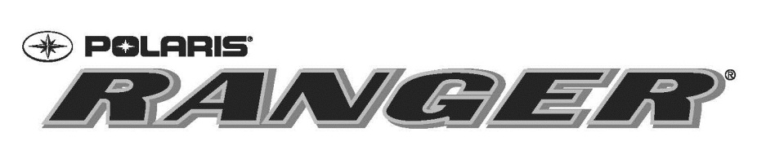

Contact: Donna Beadle
Polaris Sales Inc.
2100 Highway 55
Medina, MN 55340
Phone: 763.542.2314
donna.beadle@polarisind.com

Polaris RANGER Becomes National Sponsor of PRCA ProRodeo

Minneapolis, March 4, 2015 – Polaris® Industries Inc. (NYSE: PII), the leading manufacturer of off-road vehicles and The Professional Rodeo Cowboys Association (PRCA) today announced a national partnership recognizing the industry-leading utility vehicle (UTV), Polaris RANGER, as the “Official UTV of the PRCA, the RAM National Circuit Finals Rodeo and Wrangler National Finals Rodeo.”
“Given that the majority of our members and fans reside in rural America, this partnership is a perfect fit,” stated PRCA Commissioner Karl Stressman. “Polaris RANGER’s commitment to ProRodeo truly shows the marketing efficacy of this sport and we are proud to have them onboard.”
The newly-formed partnership includes Polaris RANGER joining the PRCA’s family of national sponsors and serving as the Official UTV of the PRCA, the RAM National Circuit Finals Rodeo and the Wrangler National Finals Rodeo. The Wrangler National Finals Rodeo will be renamed the “Wrangler National Finals Rodeo presented by Polaris RANGER.” PRCA World Champions and all RNCFR champions, effective next month in Kissimmee, Fla., will each receive a Polaris RANGER, as well as both of the Remuda Award winners. The ProRodeo Hall of Fame and the Justin Cowboy Crisis Fund will also benefit with fundraising activities for these two entities.
“Polaris RANGER is excited to continue our support of the sport of rodeo,” said Beth Shimanski, marketing manager for Polaris. “ProRodeo participants are some of the most passionate and dedicated individuals, and this partnership lets us celebrate them and their fans. We look forward to an exciting rodeo season.”

Polaris RANGER provides the hardest-working, smoothest riding UTVs for uses ranging from farming and hunting, to recreational and off-road trips. The line-up consists of premium and value offerings with seating from two to six, in electric, gas and diesel power options to cater to a wide variety of consumer needs.

More information about Polaris RANGER can be found at http://www.polaris.com/en-us/ranger-utv and on the Polaris ATV RANGER Facebook page at https://www.facebook.com/#!/PolarisRANGERATV.

About Polaris
Polaris is a recognized leader in the powersports industry with annual 2014 sales of $4.5 billion. Polaris designs, engineers, manufactures and markets innovative, high quality off-road vehicles, including all-terrain vehicles (ATVs) and the Polaris RANGER® and RZR® side-by-side vehicles, snowmobiles, motorcycles and on-road electric/hybrid powered vehicles.

Polaris is among the global sales leaders for both snowmobiles and off-road vehicles and has established a presence in the heavyweight cruiser and touring motorcycle market with the Victory® and Indian Motorcycle® and Slingshot® brands. Additionally, Polaris continues to invest in the global on-road small electric/hybrid powered vehicle industry with Global Electric Motorcars (GEM), Goupil Industrie SA, Aixam Mega S.A.S., and internally developed vehicles. Polaris enhances the riding experience with a complete line of Polaris Engineered Parts, Accessories and Apparel, Klim branded apparel and ORV accessories under the Kolpin®, Cycle Country® and Pro Armor® brands.

Polaris Industries Inc. trades on the New York Stock Exchange under the symbol “PII”, and the Company is included in the S&P Mid-Cap 400 stock price index.

Information about the complete line of Polaris products, apparel and vehicle accessories are available from authorized Polaris dealers or anytime at www.polaris.com.

About The PRCA

The PRCA, headquartered in Colorado Springs, Colo., is the largest and oldest professional rodeo-sanctioning body in the world. The recognized leader in ProRodeo, the PRCA is committed to maintaining the highest standards. The PRCA, a membership-based organization, sanctions approximately 600 rodeos annually, and there are more than 30 million fans in the U.S. The PRCA showcases the world’s best cowboys by televising the sport's premier events, including the Wrangler Champions Challenge and the world-renowned Wrangler National Finals Rodeo on CBS Sports Net (DISH channel 158, DirecTV channel 221). The Justin Boots Playoffs and Championships, RAM National Circuit Finals Rodeo, and the All American ProRodeo Finals will also air on CBS Sports Net. PRCA-sanctioned rodeos raise more than $26 million for local and national charities. For comprehensive coverage of the cowboy sport, read the ProRodeo Sports News, the official publication of the PRCA, and for daily updates of news and results visit the PRCA's official website, www.prorodeo.com.
###

