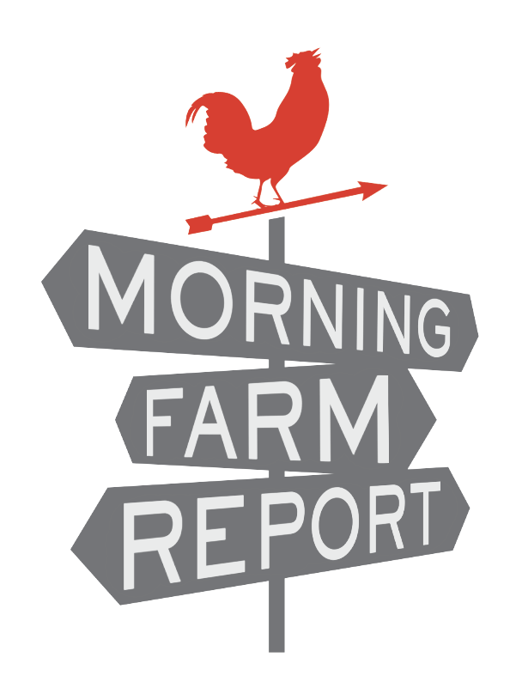
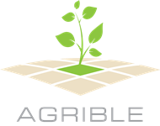

Agricultural Technology Startup Launches Morning Farm Report

CHAMPAIGN, ILLINOIS - Agrible, Inc. today launched Morning Farm Report, a predictive analytics tool that delivers field-specific data and forecasts to help with decision making in the field. Designed for growers and agricultural companies, Morning Farm Report uses a subscription model to provide reports and big data views of rainfall, temperature, growing degree days, field work logistics, maximum ground pressures, and yield estimates.

"With Morning Farm Report, we want to provide growers with data that not only helps them with their daily decision making, but with forecasts that help with weekly, monthly, and seasonal planning," said Chris Harbourt, CEO of Agrible, Inc. "Many of our developers are farmers themselves, so we know what growers are looking for and always strive to create products that we would use ourselves."

Morning Farm Report launched with four tiered products: Rainfall, Field Intel, Tractor Time Logistics, and Yield Engine. All products are priced for unlimited fields and contain all features found in lower tiered options. For example, a subscription to Tractor Time Logistics also contains all of the features of Field Intel and Rainfall. Users choose a yearly subscription to whichever product best fits their operation. There is also the option to create a custom package based on specific needs.

Rainfall, priced at $149, shows rainfall totals for your fields and allows comparisons to other fields in the county, agricultural statistical district, state and US market. Field Intel, priced at $399, adds temperature data and growing degree days, and points out pre-planting data trends and post-planting data relevant to critical periods for corn and soybeans. Tractor Time Logistics, priced at $899, predicts changes to the soil environment for up to 14 days in the future and gives recommendations on fieldwork. Yield Engine, priced at $1499, models 11 different crops throughout the season and provides weekly and seasonal estimates.

"We are building the premier company in actionable predictive analytics for agriculture with a team of truly amazing professionals," said Harbourt. “Put simply, Morning Farm Report predicts how weather will impact crops and operations.”

Developed by an expert team in Champaign, Illinois, Morning Farm Report combines soils data, custom crop growth simulations and weather data to develop its products. Data sources include the National Oceanic and Atmospheric Administration (NOAA) and the National Weather Service (NWS).

Agrible also recently launched Pocket Rain Gauge, a free iPhone application that uses the same technology as Morning Farm Report to show 24-hours of rainfall measurements. Pocket Rain Gauge uses geolocation to deliver accurate rainfall measurements for wherever the user is standing.

More information about Morning Farm Report and Pocket Rain Gauge can be found at MorningFarmReport.com

About Agrible, Inc.

Agrible is an actionable predictive analytics provider in agriculture. They predict how weather will impact crops, agricultural operations, and economic decisions. Agrible aims to make big data helpful instead of overwhelming, to innovate existing production methods, and to be the leading voice of recommendation for our agricultural partners. Above all, they value the role of the farmer, and work tirelessly to bring the most accurate, practical information to those who need it. Learn more at agrible.com.

Contact:
Keith Hollenkamp
877-522-2093
media@agrible.com

