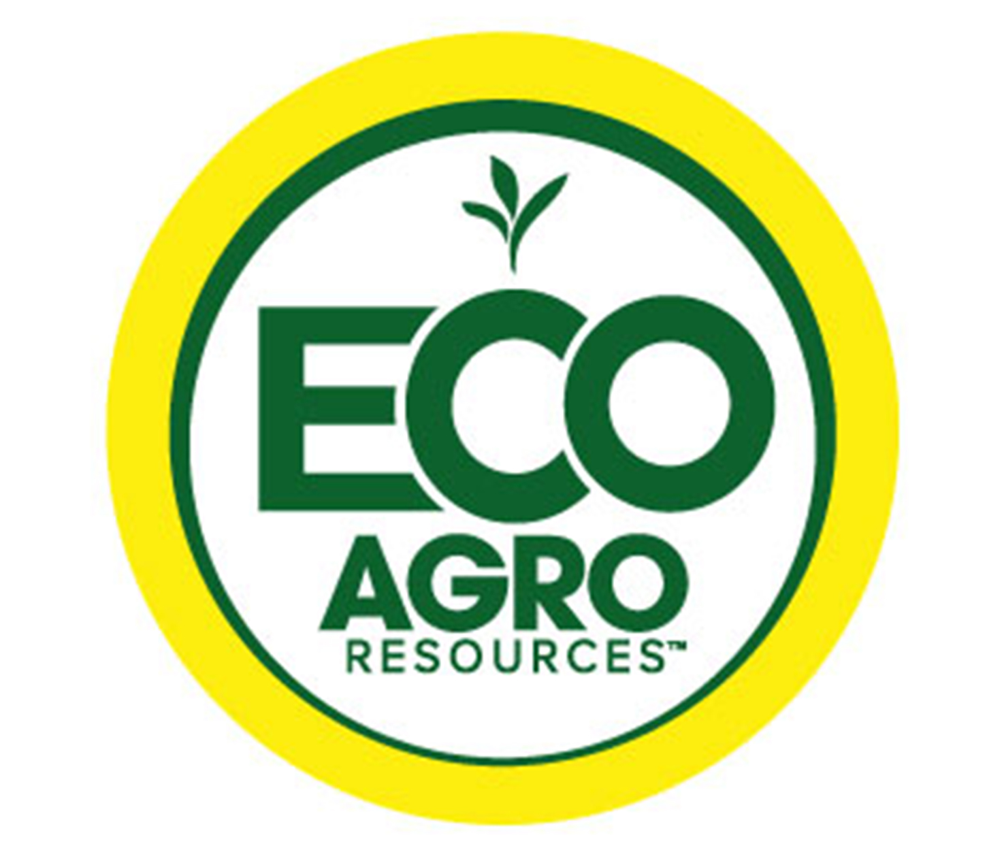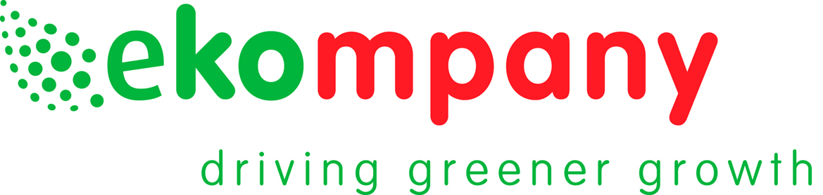

Eco Agro Resources teams with Ekompany
expanding efficiencies for growers with
unique controlled-release fertilizers

Sarasota, FL– US-based Eco Agro Resources announced today a commercial agreement expanding its product range to include Ekote, a line of eco-friendly controlled-release fertilizers by Ekompany. Ekompany based in the Netherlands and Eco Agro Resources of the United States will work together leveraging the latest technology of both companies to bring innovative products to agriculture and horticulture markets in North America.

Andrew Semple, CEO of Eco Agro Resources anticipates great demand for an alternative source of controlled release fertilizers in the North American markets especially when they are manufactured in a more sustainable fashion. Ekompany developed Ekote coated mineral fertilizers with an eco-friendly patented process. The process and the resulting enhanced efficiency fertilizer significantly reduce the carbon footprint and greenhouse gas emissions as compared to conventional processes and fertilizers. Sustainable organic polymers are used and harmful solvents are eliminated from the coating process. This new generation of controlled release fertilizer allows macro- and micro-nutrients as well as minerals to be delivered over a prescribed time period. By releasing just what the plant needs when it needs it, crop growth is maximized while minimizing environmental loss of nutrients.

Eco Agro Resources is a company focused on increasing efficiency in agricultural systems by bringing new technologies to traditional inputs. Andrew Semple, CEO of Eco Agro Resources observes, “Today’s agriculture and horticulture industries need input efficiencies. Fertilizers like Ekote deliver the nutrients needed, without product being lost to the environment. Our corporation working with Ekompany and their Ekote technology will allow us to meet the needs of our customers for highly-efficient technologies. ”

“We are excited to enter the North American market and are eager to introduce new formulas and solutions together with Eco Agro Resources to meet the needs of the local growers and farmers. Our state-of-the-art technology has demonstrated proven quality in both lab conditions as well as on the field, in different regions and climates world wide, and I am confident the results will be excellent here as well.” states Eric van Kaathoven, CEO and founder of Ekompany.

For more information, visit: www.ecoagro.com and www.ekompany.eu

###

About Eco Agro Resources:
Eco Agro Resources is a USA based nutrient efficiency company dedicated to the development and commercialization of technologies to help farmers grow crops more efficiently. With offices located in Florida, Texas, Illinois, North Carolina, Arkansas, Minnesota, China and Brazil, Eco Agro Resources is providing innovative and quality products to the agricultural nutrient market, with focus on an economic, agronomic and responsible approach. Learn more at www.ecoagro.com.

About Ekompany:
Ekompany Agro B.V. is a Dutch manufacturer of professional coated mineral fertilizers with a production facility and head office in Born, the Netherlands. Ekompany’s factory is exclusively specialized in controlled release fertilizers (CRF) and is the largest of its kind in Western Europe. Ekompany uses an advanced patented production process that is cleaner, more efficient and economical than other CRF production processes. The product assortment contains a wide selection of controlled release fertilizers with a reference longevity of 3 to 18 months. The Ekompany products are internationally available under the registered trade name Ekote.

For more information contact:

Andrew Semple
Chief Executive Officer
ECO AGRO RESOURCES
6151 Lake Osprey Drive
Sarasota, Florida 34240
Phone: (941) 256-3377

Eric van Kaathoven
Chief Executie Officer
Ekompany Agro B.V.
Verloren van Themaatweg 2A
6121RG Born, The Netherlands
Phone: +31 (0)46 727 1002
E-mail: info@ekompany.eu

