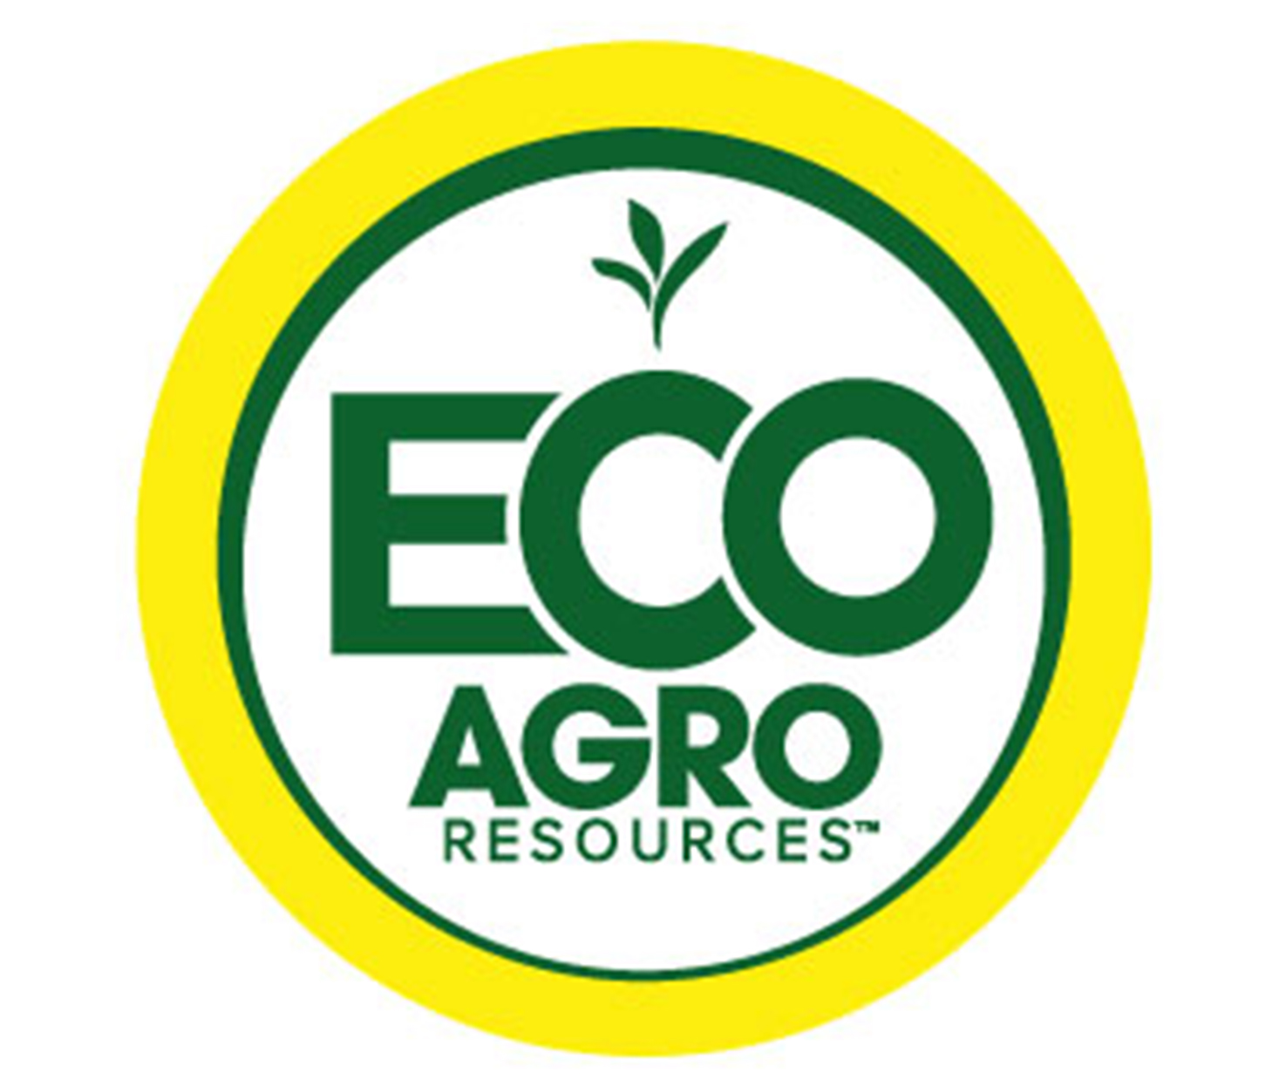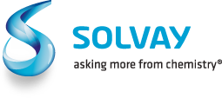

Solvay Novecare & Eco Agro Resources join forces

Cranbury, NJ Feb. 9, 2015 - Solvay's global business unit Novecare announced today that it will team up with US-based Eco Agro Resources to develop market and product portfolio opportunities in North and South America.

The partnership is part of larger discussions aimed at leveraging the companies' combined enhanced efficiency fertilizer products (EEFs) for agricultural distributors and customers. The partnership was announced today at the start of The Fertilizer Institute's annual conference in Scottsdale, Arizona.

Andrew Semple, CEO of Eco Agro Resources, sees the partnership as a natural evolution of the business. "We've worked to identify and develop novel technologies to bring to the agricultural marketplace. To accomplish this takes the right people and relationships. Solvay Novecare's culture, portfolio, and customer and market focus complements our own strategy and offerings."

Formed last year, Eco Agro Resources is a specialty chemicals developer based out of Florida with a strong pedigree in nitrogen stabilizers and phosphorus enhancers. Solvay Novecare is one of the industry's fastest growing specialty chemical players serving the agrochemicals, coatings, home & personal care, industrial and oil & gas markets. Its agrochemical portfolio includes sustainable solutions for fertilizer and crop protection, soil and water management, and anti-drift formulations for pesticides.

###

Eco Agro Services Eco Agro Resources is a USA based nutrient efficiency company dedicated to the development and commercialization of technologies to help farmers grow crops more efficiently. With offices located in Florida, Texas, Illinois, North Carolina, Arkansas, Minnesota, China and Brazil, Eco Agro Resources is providing innovative and quality products to the agricultural nutrient market, with focus on an economic, agronomic and responsible approach. Learn more at www.ecoagro.com.

Solvay Novecare is a worldwide leader in specialty surfactants and a major player in polymers, amines, guar, and phosphorus derivatives. Solvay Novecare engineers and develops formulations that provide consumer products and state-of-the-art industrial applications with specific functional qualities designed to modify fluid behavior and deliver cleansing, dispersal, gelling, moisturizing, penetrating, softening or texturizing properties. These formulations are used in shampoos, detergents, paints and lubricants as well as in crop protection, mining and energy production and stimulation. Novecare, which boasts a worldwide network of 36 manufacturing sites and nine R&D centers, has become the preferred partner of its customers in rapidly growing economies and leverages an innovation platform based on sustainable solutions.

As an international chemical group, SOLVAY assists industries in finding and implementing ever more responsible and value-creating solutions. Solvay generates 90% of its net sales in activities where it is among the world's top three players. It serves many markets, varying from energy and the environment to automotive and aeronautics or electricity and electronics, with one goal: to raise the performance of its clients and improve society's quality of life. The group is headquartered in Brussels, employs about 29,400 people in 56 countries and generated 9.9 billion euros in net sales in 2013. Solvay SA (SOLB.BE) is listed on EURONEXT Brussels and EURONEXT Paris (Bloomberg: SOLB:BB - Reuters: SOLB.BR).
For More Information Contact:
Lamia Narcisse  Media Relations  + 33 1 53 56 59 62 | Caroline Jacobs  Media Relations  + 32 2 264 1530 | Maria Alcon-Hidalgo  Investor Relations  + 32 2 264 1984 | Edward Mackay  Investor Relations  + 32 2 264 36 87
 | MARK WHEELER  Novecare  Media Relations  (609) 860-3910 | JEFF WHETSTINE  Eco Agro Resources  Media Relations  (314) 440.4248

